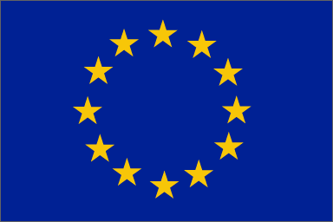
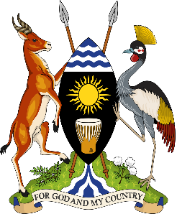

Development Initiative for Northern Uganda (DINU)
11th European Development Fund
Under the Financing Agreement No. FED/2016/038-781

Call for Concept Notes
Reference: EuropeAid/164469/Indirect Management/ACT/UG

CLARIFICATIONS TO QUESTIONS RECEIVED
1ST SET OF QUESTIONS: Nos. 1-11

Publication Date: 11 June 2019

Question | Answer/Clarification
ELIGIBILITY CRITERIA QUESTIONS
- Can Non-Governmental Organisations/Civil Society Organisations be co-applicants? | Specific type of organisations such as Non-Governmental Organisations/Civil Society Organisations are eligible as co-applicants as specified under section 2.1.1 in the Guidelines for Applicants, page 11.
- Are urban local governments eligible to apply? | Specific type of organisations such as local governments are eligible as lead applicants, co-applicant(s) and affiliated entity(ies), and/or associates as specified under section 2.1.1 in the Guidelines for Applicants, page 11.
- Can institutions operating under NARO apply separately or apply under NARO? | Specific type of organisations such as public sector operators are eligible as lead applicants, co-applicant(s) and affiliated entity(ies), and/or associates as specified under section 2.1.1 in the Guidelines for Applicants, page 11.
- Can a district as lead applicant partner with the municipal council as a co-applicant to ensure compatibility of applicants? | Specific type of organisations such as municipal councils are eligible as co-applicants as specified under section 2.1.1 in the Guidelines for Applicants.
- Is it allowed to partner with the private sector to do some scale-up model? | Specific type of organisations such as private companies are eligible as lead applicants, co-applicants, affiliated entities or associates as specified under section 2.1.1 in the Guidelines for Applicants, page 11
- Are entities registered in the UK eligible as OECD members regardless of the outcome of Brexit? | All OECD members are eligible given that Uganda is an LDC.
- Clarify the eligibility of entities registered in African, Caribbean and Pacific (ACP) countries? | Applicants established in an ACP State and meet all the requirements under section 2.1.1 in the Guidelines for Applicants are eligible to apply under this Call.
- Can an organisation registered in Kenya be eligible to apply as a co applicant with a lead NGO established both in EU member state as well as in Uganda? | Applicants established in an ACP State and meet all the requirements under section 2.1.1 in the Guidelines for Applicants are eligible to apply under this Call.
- Can an international research organization that is not headquartered in Uganda be eligible to apply? | As specified in section 2.1.1 in the Guidelines for Applicants, the obligation to be established in an ACP state, a member state of the European Union, the European Economic Area or the OECD and Overseas Countries and Territories does not apply to International Organisations.
- Could you clarify the issue related to the following paragraph regarding the obligation that doesn’t apply to international organisation and the following sentences;  - be a legal person and  - be a specific type of organisation such as: non-governmental organisation, private sector organisation, public sector operator, foundation, cooperative or association, local government, international (inter-governmental) organisation as defined by Article 43 of the rules of application of the EU Financial Regulation and  - be established in an ACP state, a member state of the European Union, the European Economic Area or the OECD and Overseas Countries and Territories. | As specified in section 2.1.1 in the Guidelines for Applicants, the obligation to be established in an ACP state, a member state of the European Union, the European Economic Area or the OECD and Overseas Countries and Territories does not apply to International Organisations.
- Could you clarify if a European Non-governmental organisation established in a member state of the European Union that is part of a family that also has a member of the family with a stable operational presence in the Republic of Uganda is eligible as applicant or co-applicant of the call for proposal. | Applicants established in a member state of the European Union, the European Economic Area or the OECD and Overseas Countries and Territories and meet all the requirements under section 2.1.1 in the Guidelines for Applicants are eligible to apply under this Call.

